Assignment : ICMP Pinger
Name : Surbhi Thole
NetId: sst390

Code:

from socket import *
import os
import sys
import struct
import time
import select
import binascii
import socket

ICMP_ECHO_REQUEST = 8
RTT = []
sent = 0;
Recieve = 0;

def checksum(str):
csum = 0
countTo = (len(str) / 2) * 2
count = 0
while count < countTo:
thisVal = ord(str[count + 1]) * 256 + ord(str[count])
csum = csum + thisVal
csum = csum & 0xffffffffL
count = count + 2
if countTo < len(str):
csum = csum + ord(str[len(str) - 1])
csum = csum & 0xffffffffL
csum = (csum >> 16) + (csum & 0xffff)
csum = csum + (csum >> 16)
answer = ~csum
answer = answer & 0xffff
answer = answer >> 8 | (answer << 8 & 0xff00)
return answer

def receiveOnePing(mySocket, ID, timeout, destAddr):
global Recieve, RTT
timeLeft = timeout
while 1:
startedSelect = time.time()
whatReady = select.select([mySocket], [], [], timeLeft)
howLongInSelect = (time.time() - startedSelect)
if whatReady[0] == []: # Timeout
return "Request time out"
time_rec = time.time()
recPacket, addr = mySocket.recvfrom(1024)
# Fill in start
# Fetch the ICMP header from the IP packet
icmpHeader = recPacket[20:28]
Type, code, revChecksum, recId, recSequence = struct.unpack('bbHHh', icmpHeader)
print "Type : ",Type, " Code : ", code, " ID : ", recId, " Sequence: ", recSequence
if ID == recId:
bytesInDouble = struct.calcsize('d')
timeData = struct.unpack('d', recPacket[28:28 + bytesInDouble])[0]
RTT.append(time_rec - timeData)
Recieve += 1
return time_rec - timeData
else:
return "ID is different!"
# Fill in end
timeLeft = timeLeft - howLongInSelect
if timeLeft <= 0:
return "Request time out"

def sendOnePing(mySocket, destAddr, ID):

global sent
# Header is type (8), code (8), checksum (16), id (16), sequence (16)

myChecksum = 0

# Make a dummy header with a 0 checksum.
# struct -- Interpret strings as packed binary data
header = struct.pack("bbHHh", ICMP_ECHO_REQUEST, 0, myChecksum, ID, 1)
# Calculate the checksum on the data and the dummy header.
data = struct.pack("d", time.time())
myChecksum = checksum(header + data)
# Get the right checksum, and put in the header
if sys.platform == 'darwin':
myChecksum = socket.htons(myChecksum) & 0xffff
# Convert 16-bit integers from host to network byte order.
else:
myChecksum = socket.htons(myChecksum)
header = struct.pack("bbHHh", ICMP_ECHO_REQUEST, 0, myChecksum, ID, 1)
packet = header + data
mySocket.sendto(packet, (destAddr, 1))
sent += 1
# AF_INET address must be tuple, not str
# Both LISTS and TUPLES consist of a number of objects
# which can be referenced by their position number within the object

def doOnePing(destAddr, timeout):
icmp = socket.getprotobyname("icmp")
# SOCK_RAW is a powerful socket type. For more details see:http://sock-raw.org/papers/sock_raw
# Fill in start
# Create Socket here
try:
mySocket = socket.socket(socket.AF_INET, socket.SOCK_RAW, icmp)
except socket.error, (errno, msg):
if errno == 1:
raise socket.error(msg)
# Fill in end
myID = os.getpid() & 0xFFFF # Return the current process i
sendOnePing(mySocket, destAddr, myID)
delay = receiveOnePing(mySocket, myID, timeout, destAddr)
mySocket.close()
return delay

def ping(host, timeout=1):
# timeout=1 means: If one second goes by without a reply from the server,
dest = socket.gethostbyname(host)
print "Pinging " + dest + " using Python:"
print ""
# Send ping requests to a server separated by approximately one second
while 1:
delay = doOnePing(dest, timeout)
print delay
time.sleep(1) # one second
return delay

ping("www.bom.gov.au")

1) Asian Continent: ping(“www.mu.ac.in”)

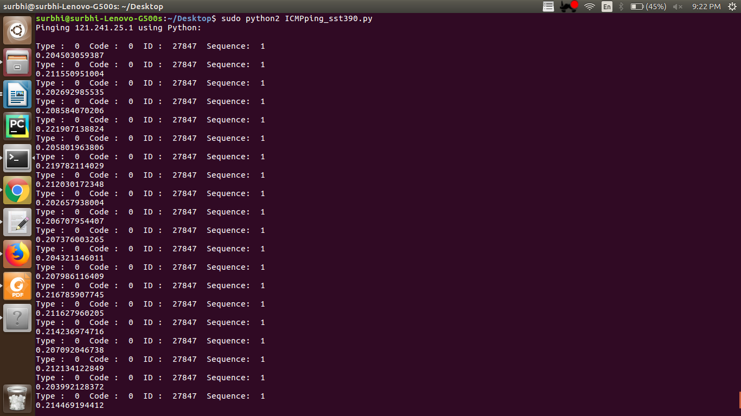
2) North – American Continent: ping(“www.amazon.com”)

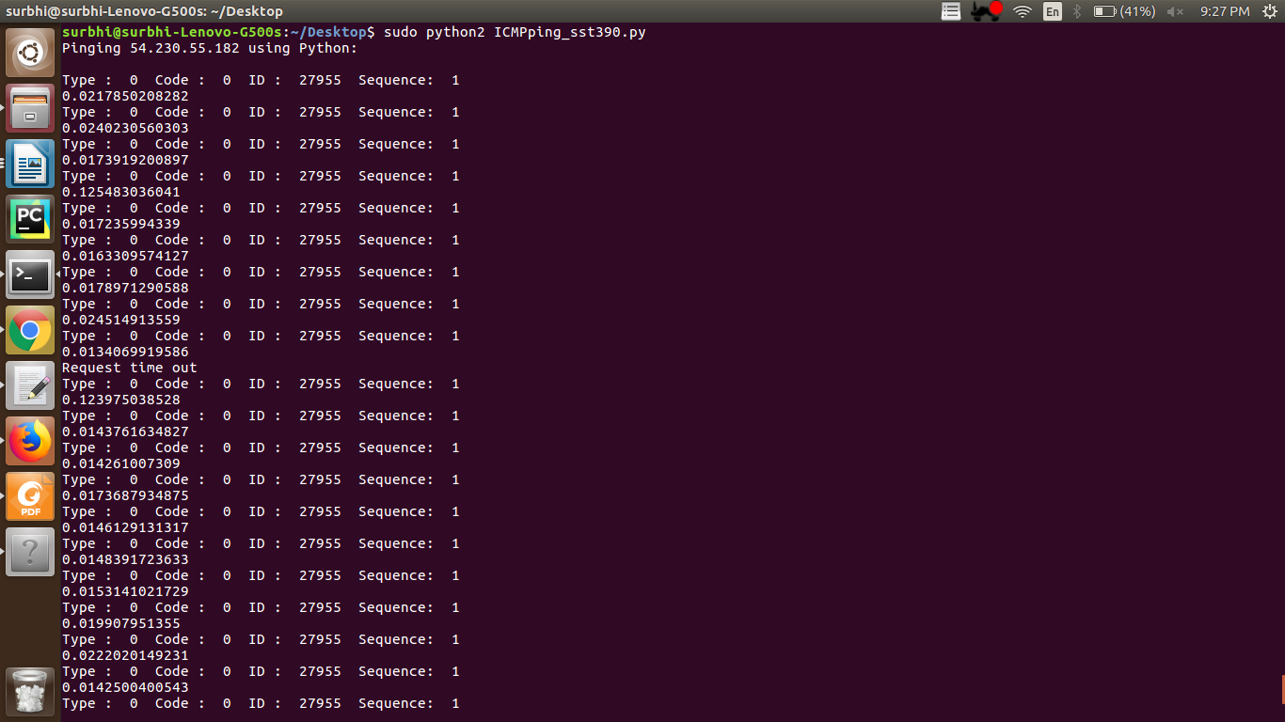

3) European continent : ping(“www.politico.eu”)

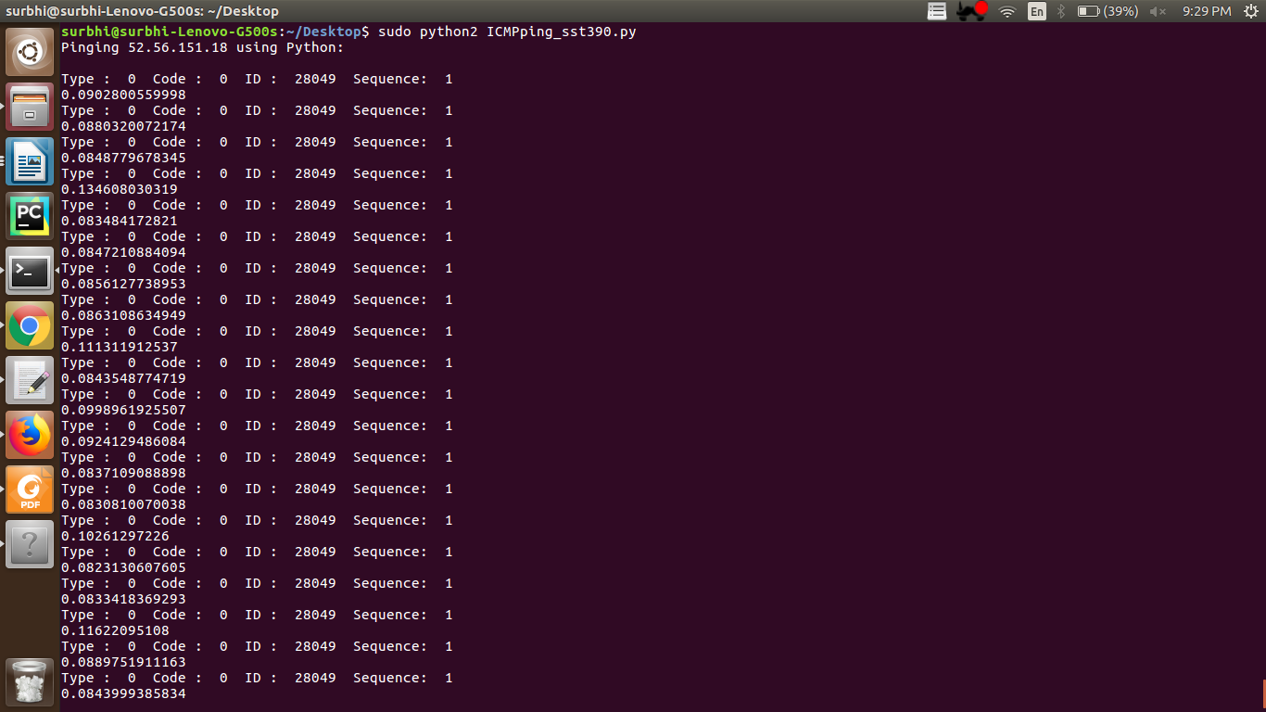
4) Australia : ping(“www.bom.gov.au”)

